## Preferences

### General

With the field “Preferences” (see Figure 2‑11), you can set several personal preferences. For example, you can set the software language, set the ships heading references as well as configure the SMS service.

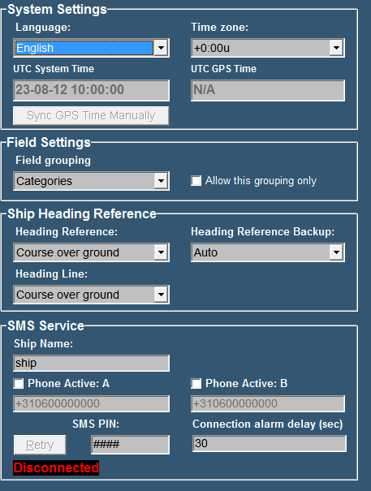

Figure 2‑11: Preferences

### System Settings

By clicking the “Language” arrow, all supported software languages appear.

Simply click on one of these languages to set the default language for all software modules.

By clicking the “Time zone” arrow allows you to set the relevant UTC[1] time zone.

As soon as a GPS is connected to the system NavVision will use this GPS to set the time. In this case you won’t have to alter the “Time Zone” while it will be taken care of by the GPS. If you think the time is not right, you can click “ Sync GPS time manually”.

### Field Settings

Under “Field Grouping” you can choose in which order you want to see all the fields in “field settings”. You can change the order to “Categories” or to “ Alarm Groups” The last one will come in handy when you are checking whether all the fields are in the right Alarm Group.

### Ship heading reference

This option allows you to choose the default references for heading, heading backup and heading line. The options range from Auto to Course over ground, Gyro compass, true compass and magnetic compass.

### SMS service (ship name)

Ship name is used to enter your ship’s name into the software. Of course, the name is entirely your own choice and has no influence on the software’s functions.

### SMS service (phone active A & B)

*:*

*When entering a phone number always include your country code.*

Phone activate A/B are used to store the telephone numbers of one or two mobile phones you want to receive text-messages with. First, tick off the checkbox for each phone in use and enter the phone-number of your choice.

### SMS service (SMS PIN)[2]

Via the field SMS PIN, enter a personal code (any combination), used to establish a connection in between your phone and the system. The black box below shows whether a connection is established or not.

|  |  |
| --- | --- |
| **Detail** | **Description** |
| Connected | Indicates that a connection is made. Alarm messages are allowed to be sent to your mobile phone. |
| Disconnected | Indicates that no connection is made. No alarm messages to be allowed. |

1. UTC = Universal Time Coordinated
2. Functionality only applicable with SMS hardware module + license